NCC Fab Lab Access Guidelines
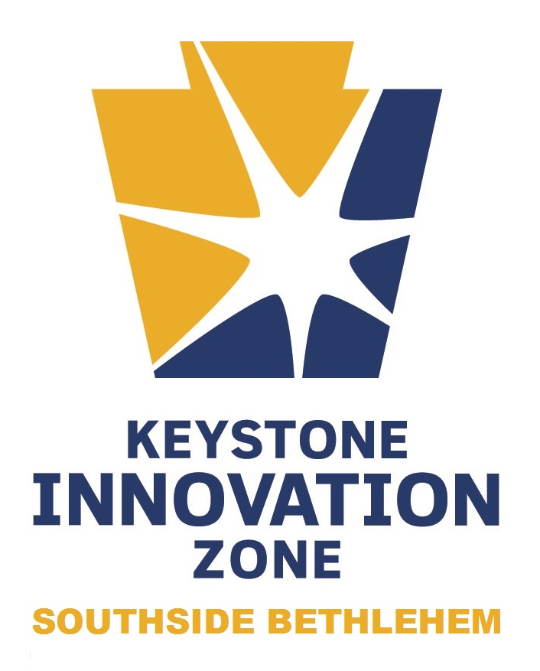

It is the mission of the Southside Bethlehem Keystone Innovation Zone (KIZ) to foster innovation and create entrepreneurial opportunities by aligning the combined resources of educational institutions, the public sector, and the private sector.

In support of this mission, the KIZ may allocate up to $1,000 in expenses accrued at the Northampton Community College Fab Lab in order to assist eligible applicants in the commercialization of innovative technologies that possess promise for technology transfer into the marketplace. The purpose of this program is to support the development of innovative, revenue-generating, and marketable technologies, support company growth, and facilitate job creation within the KIZ and the Commonwealth of Pennsylvania. Funding for this program is provided exclusively by the KIZ’s Primary Partners.

Eligibility Requirements

Eligible Applicants for NCC Fab Lab Access must be:

- an entity that meets the following requirements:
  - Located within the geographical boundaries of the KIZ
  - Operational for less than 8 years
  - Operating within one of the State-approved industry clusters. Further preference will be given to the following industry clusters approved by the Southside Bethlehem KIZ:
    - Information Technology
    - Financial Services
    - Advanced Materials
    - Nanotechnology
    - Opto/Micro Electronics
    - Life Sciences
    - Energy
  - Meets any other requirements that may be specified
- a Primary Partner that clearly demonstrates an ability to generate innovative, revenue-generating, and marketable technologies. The potential should exist to transfer the technology to a spin-off company and/or pursue licensing opportunities.

Usage Requirements

- A applicant interested in utilizing resources through this program will set up an initial consultation with the NCC Fab Lab Director:
Jeff Boerner
jboerner@northampton.edu
(610) 332-8665
- Applicant will work with NCC Fab Lab Director to ensure that tracking and compliance methods approved by the KIZ Director are being followed.
- Eligible expenses accrued by the applicant only apply to prototyping and commercialization of a revenue-generating product, service, or technology.
- Applicant may not exceed $1,000 of eligible expenses per calendar year. If this does occur, applicant is responsible for any costs above and beyond this amount.
- Eligible expenses are briefly summarize below:
  - Monthly Membership (approved on a case-by-case basis)
  - Standard Fab Lab Fees:
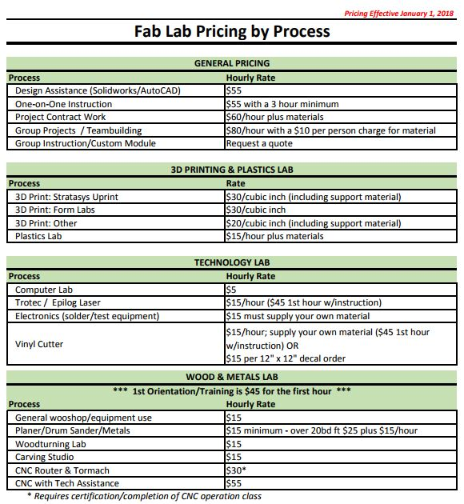

Reporting Requirements

Company will be responsible for any reporting required by the KIZ Director

State Partner

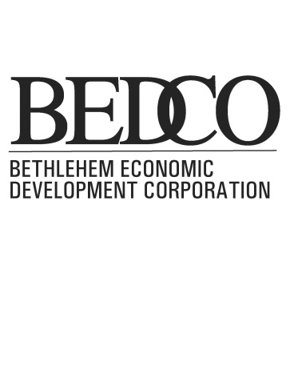
Primary Partners
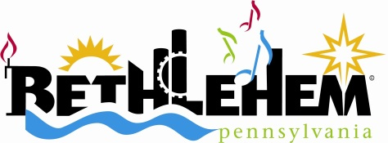
Northampton County GPA

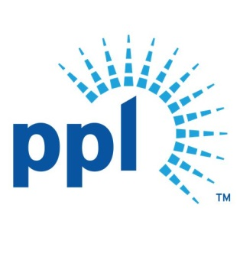

Advisory Partners
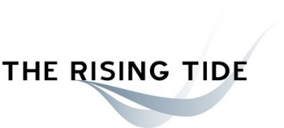

Attachment A

eligibility form

Company information
Name:
Company FEIN: |  | FEIN Filing Date:
Company Address: |  |  |  | Suite:
City: |  | State: |  | ZIP Code:
Company HQ Address: [only complete if different from above] |  |  |  | Suite:
City: |  | State: |  | ZIP Code:
Date Located at Address: |  | #of Employees Working in KIZ: |  | # of Employees in Company:
Company Description:
NAICS Code: | NAICS Description:
Identify the Following Industry Clusters that are Applicable to your Company:
Information Technology/Financial Services
Advanced Materials/Nanotechnology
Opto/Micro Electronics
Life Sciences
Energy
Description of any Patents, Trademarks, Copyrights:
Description of Innovative Nature of Company:
Employment Goals:
How Did You Hear About the KIZ?

Applicant Information
Name: |  |  | Title:
Phone: |  |  | Email:
Name: [complete if CEO/President is different than above] |  |  | Title:
Phone: |  |  | E-mail:

Authorization
By signing this document, I approve this information and certify that it is correct to the extent of my knowledge.

Company:
Name:
Title:

Signature: X
Date:
Required documentation:
- Business Plan
- Proof of ownership/lease
- Proof of FEIN filing date

